Analyzing the Orbital Behavior of Exoplanets

Introduction:

In this report, I will outline my approach towards analyzing the orbital behavior of planets outside our solar system. I will provide summaries of my use of data analysis, fitting, filtering, and modeling. Additionally, I will provide a visualization of my data and analysis that confirms a relationship between Kepler’s Third Law and the behavior of exoplanets as recorded in NASA’s exoplanet archive.

Data Source:

The phenomenon that I have chosen to study is the motion of planets around a host star and its relation to Kepler’s Third Law. I used data from the NASA exoplanet archive to study the orbital parameters and masses of the stars and planets. The parameters I needed to draw from this source were for each planet the period, semi major axis, planet mass, and host star mass.

Equation to Fit Data:

According to my experience, Kepler’s Third Law would be an interesting equation to use to fit this data. I want to find data that confirms the relationship defined by Kepler’s equation below, where P is the period in years, a is the semi-major axis in AU, Mtot is the sum of the planet and host star masses, and k is the Gaussian gravitational constant.

After using this version of Kepler’s law to fit the data and realizing the relationship wasn’t as clear as I wanted, I decided to modify this equation to account for the various host star masses that systems may have. The new formula that was used to fit the data is: A math equation with a square and a line

In the code, it is in the form of this function:

def keplers_third_law(period, k, m_planet, m_star):

period_squared = period ** 2

m_total = m_planet + m_star

semi_major_axis = np.sqrt((k * period_squared) / (4 * np.pi ** 2 * m_total))

return semi_major_axis

Data Generation:

I generated random testing data to evaluate my model and ensure it was applicable.

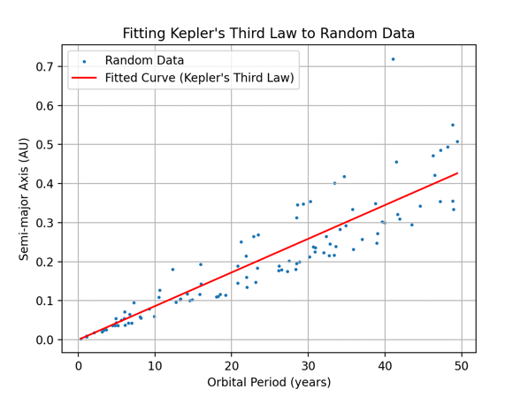

Data Filtering

I applied these filtering methods:

1. Outlier Removal:

I noticed large gaps in my data between very small values and a few very large values. While fitting the entire data set to Kepler’s Law wasn’t unsuccessful, I decided the data would be better visualized and analyzed on a small scale, so I only considered data with periods of less than 100 years when reading the csv file. This decision was also driven by the background knowledge that observations and calculations about exoplanets are more accurate when the systems have short periods, because there is more transit data that can be collected over time.

1. Missing Data:

The operations required to fit the data did not work when data was missing in certain rows. To combat this, I used a simple conditional that only added data to the lists if all necessary rows had a value assigned.

Data Fitting with Error

I fit my data with Kepler’s Third Law and considered error while doing so. The fitting parameters are printed alongside with the residuals between the curve fit and the original data to further confirm that Kepler’s Law is a good fit.

Fitted parameters:

Period: 0.5613394576167962 years

Semi-major Axis: 784.6094491626077 AU

Mean residual: 0.02188405779945395

Median residual: 0.026769383451940944

Standard deviation of residuals: 0.024617651875285647

Maximum residual: 0.4016893977173361

Minimum residual: -0.14407109545592925

This is the plot that fits the NASA data to Kepler’s Third Law, and the error quantification for this fitting process. The numbers for residual are very low, which indicates that the fitted curve captures the trend of the data very well, indicating that the model works even with error considered.

My Conclusion

Because Kepler’s Third Law proved to be a good fit for my data when considering only small periods and axes, we can draw conclusions about the behavior of exoplanets regardless of how different their characteristics are from earth and the sun. The alignment of the generated test data with the model of Kepler’s Third Law suggests it to be a good representation of any given period/semi-major axis pair, as the equation applies to realistic scenarios where error is involved. Furthermore, the adherence to Kepler’s Law of exoplanets with up to 100 times the period of earth demonstrates the durability and universality of a principle that was created up to 400 years ago.